Q. •Given:  
  
•/*1*/ thief(john).  
  
•/*2*/ likes(mary,chocolate).  
  
•/*3*/ likes(mary,wine).  
  
•/*4*/ likes(john, X) :- likes(X, wine).   
  
•Write a prolog Rule to express: John likes anyone who likes wine.

•Write a prolog Rule to express: A person may steal something if the person is a thief and the person likes the thing.

**CODE**

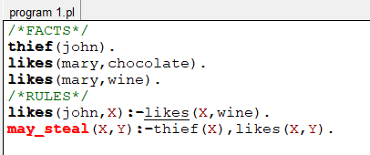

**OUTPUT (Questions)**

